# Login IDC prefab for Unity

1. Drag IDCLoginManager prefab to your scene.
2. Select IDCLoginManager object and set your game "secret" in the Inspector.

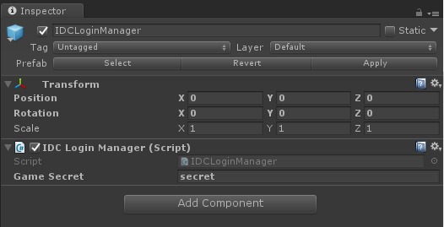

1. You can check if user is logged in reading *IsLogged* property*.*

string isLogged = IDCLoginManager.instance.IsLogged;

1. Get access to user data in your scripts:

string userId = IDCLoginManager.instance.UserId;  
string country = IDCLoginManager.instance.Country;  
string language = IDCLoginManager.instance.Language;  
string currency = IDCLoginManager.instance.Currency;  
string nick = IDCLoginManager.instance.Nick;  
string email = IDCLoginManager.instance.Email;  
string status = IDCLoginManager.instance.Status;  
string avatar = IDCLoginManager.instance.Avatar;  
string custom = IDCLoginManager.instance.Custom;

# Wolopay prefab for Unity

**Note: Wolopay prefab requires Steamworks .NET package** <https://github.com/rlabrecque/Steamworks.NET/releases>

1. Drag *WolopayManager* prefab to your scene.
2. Select *WolopayManager* object and set your *WOLOPAY_API_USER*, *WOLOPAY_API_SECRET* and Url for notificactions to your game server.

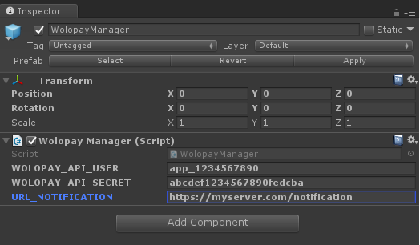

1. To open Wolopay store call to *OpenWolopay()* in *WolopayManager*.

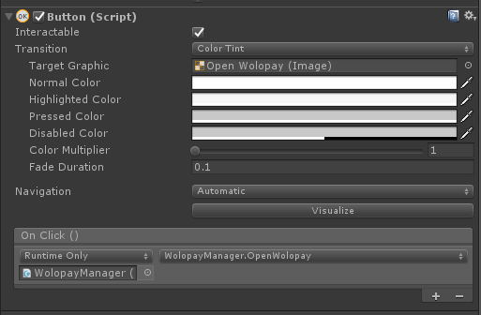

1. *OpenWolopay()* will create a new transaction automatically using the right userId:
   1. If the game is started from Steam and a user is logged in, WolopayManager will use his/her Steam User Id.
   2. If the game is started from IDCLauncher and IDCLoginManager is available in your game (see Login IDC prefab for Unity), WolopayManager will use the IDC User Id.
   3. If the game is not using IDCLoginManager prefab, you can still start Wolopay setting the UserId with the id you get from IDC Games before calling *OpenWollopay().*

WolopayManager.instance.UserId = "xxxxxxxxxx";